CLOUD COMPUTING ON

EMBEDDED SYSTEY

Project Description

* We all know that Linux has many tools that help in big projects like machine learning (Ubuntu), hacking (Kali), etc.
* But most of the time, projects are done in Windows, so if we want to switch to another operating system, we must start from the beginning.
* So, if you upload your project to the cloud via our cloud system, you can continue your project from where you stopped it in Windows operating system.
* You can convert your projects from Windows to Linux and vice versa.

Uploading Files From

Linux to Windows

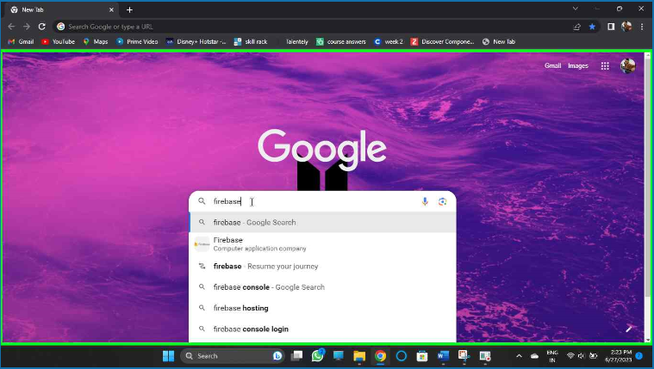

Uploading Files From

Linux to Windows

Final output

Windows to linux

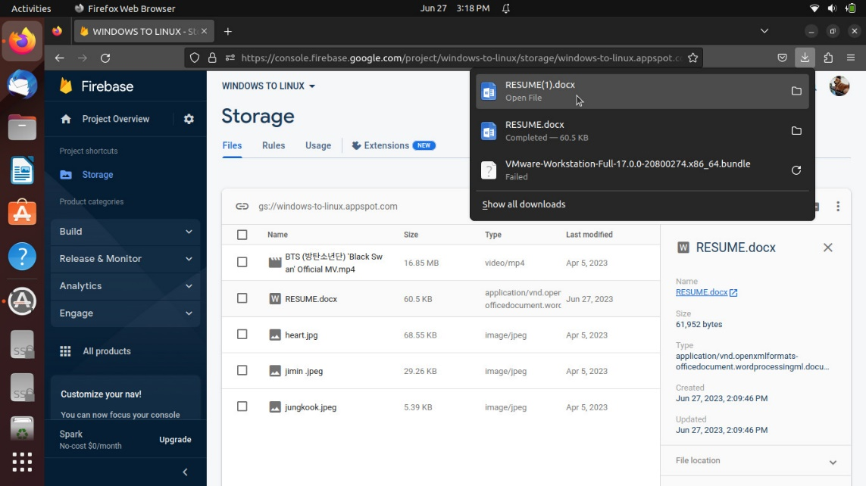

Linux to Windows

